

INT213 - PYTHON PROJECT GUI ON PIZZA MANAGEMENT SYSTEM

SUBMITTED TO DR. RAMANDEEP SANDHU

NAME – AYAN RUZDAN

SECTION – K21MR

REG NO – 12116032

ROLL NO – RK21MRA14

GROUP – 1

NAME – ARPAN CHAUDHARY

SECTION – K21MR

REG NO – 12113688

ROLL NO – RK21MRA03

GROUP – 1

NAME – VAIBHAV JAIN

SECTION – K21MR

REG NO – 12116035

ROLL NO – RK21MRA15

GROUP – 1

**TABLE OF CONTENTS**

|  |  |
| --- | --- |
| S. No. | Topic |
| 1 | Project Requirement |
| 2 | Introduction |
| 3 | Objective |
| 4 | Table Used |
| 5 | Result Screenshot |
| 6 | Roles and Responsibility of Group Members |
| 7 | Conclusion |
| 8 | References |

**PIZZA MANAGEMENT SYSTEM**

**PROJECT REQUIREMENT**

Design a system to keep the track of number of pizza orders, delivery of pizzas to a particular venue, cancellation of orders.

**INTRODUCTION**

The “Pizza Ordering System” has been developed to solve the problems prevailing in the manual system. This software is supported to eliminate and, in some cases, reduce the hardships faced by the existing system. Moreover, this system is designed for the need of the company to carry out operations in a smooth and effective manner. The application is reduced as much as possible to avoid errors while entering the data. No formal knowledge is needed for the user to use this system.

**OBJECTIVE**

The current system where the customer calls the pizzeria takes time of employees to answer the phone and is more work consuming than necessary. They want to allow customers to customize and order their pizzas online. The pizzeria also aims to increase the sales with the help of the online order system. The system will give the employees more time to work rather than to accept orders by phone, also the potential increase in customers is enough reason for the pizzeria to accept the change. The focus is to create an easy to use, which will allow a first-time customers to complete the order in ease.

**TABLE USED IN THE DATABASE**

|  |  |  |  |
| --- | --- | --- | --- |
| **Field** | **Type** | **Null** | **Key** |
| OrderId | Int | NO | PRIMARY |
| name | varchar(40) | YES |  |
| address | varchar(100) | YES |  |
| mobile | varchar(10) | YES |  |
| emailid | varchar(30) | YES |  |
| pizzatype | varchar(20) | YES |  |
| time | Text | YES |  |

**RESULT SCREENSHOT**

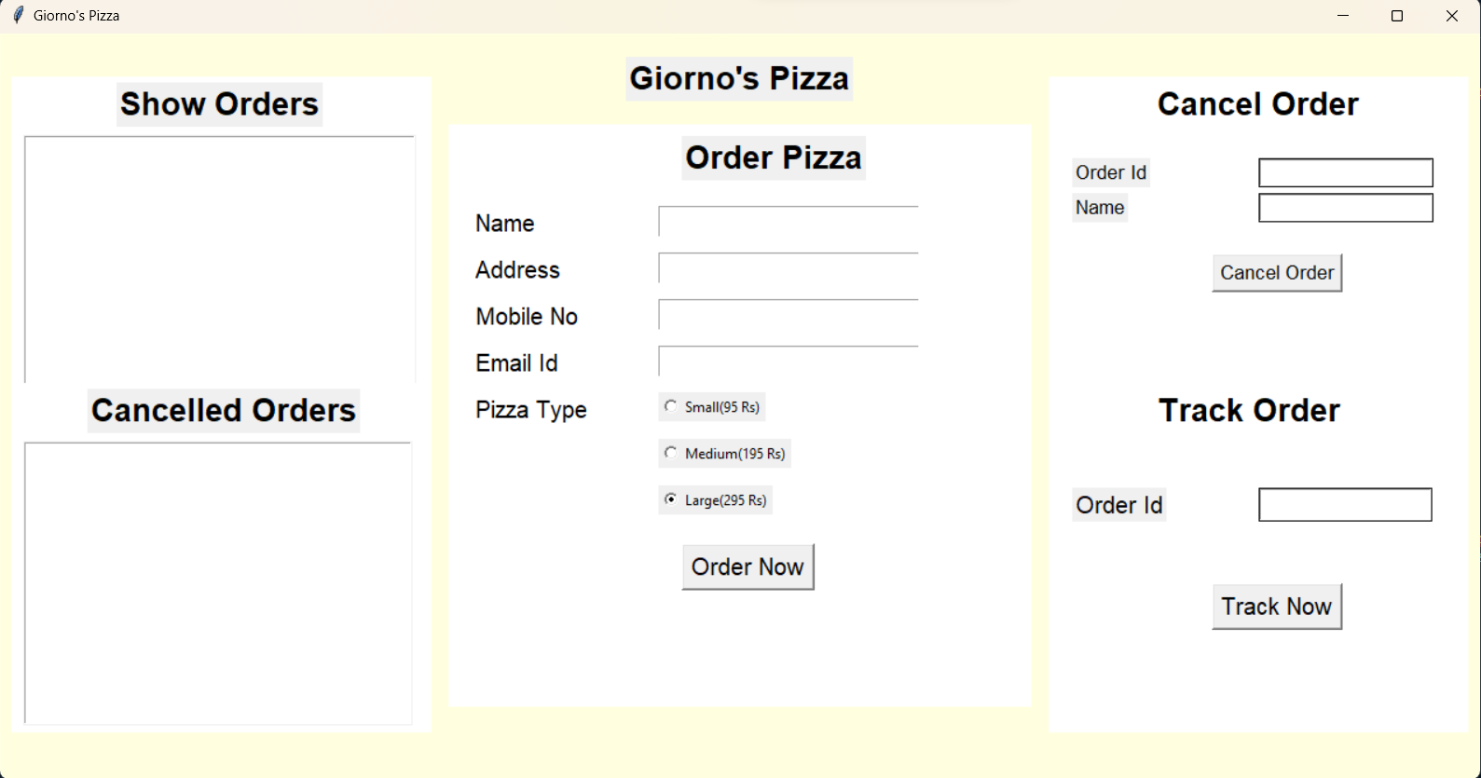

**MAIN MENU**

Allows the user to fill in their details and Pizza Type to order the pizza

**CANCEL ORDER**

Allows the user to cancel a given order and add it to the *Cancelled Orders* list

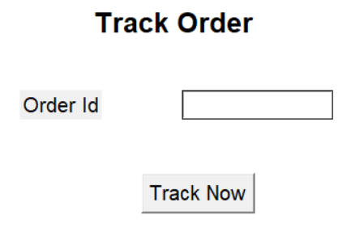

**TRACK ORDER**

Allows the user to track their pizza order

**SHOW ORDERS**

Allows the user to see already placed orders

**CANCELLED ORDERS**

Allows the users to see the list of cancelled orders

**ROLE AND RESPONSIBILITY OF GROUP MEMBERS**

Ayan Ruzdan:

Will work on the main code and GUI using Tkinter

Arpan Chaudhary:

Will work on the main program and final report.

Vaibhav Jain:

Will work on the database using MySQLdb

**CONCLUSION**

This project has really been faithful and informative. It has made us learn and understand the many concepts of Python language, as we have used Python tkinter as GUI to provide various controls such as buttons, labels and textbox to build a user-friendly pizza ordering system. The fast-growing use of Internet confirms the good future and scope of this project. Also, it has taught us a valuable lesson about the benefits of working as a group.

**REFERENCES**

* GeeksforGeeks
* Stackoverflow
* Wikipedia
* GitHub Projects
* Python.org
* Tkinter official documentation
* Introduction to Programming using Python